Web Development Tools

Mr.Yonus Thonse
Thonse Technologies
Manipal, India 576-114

Mahalaxmi Shenoy Sanjana Adiga MGM,Udupi MGM,Udupi

ABSTRACT: The Web has evolved into a global environment for delivering all kinds of application, ranging from small-scale and short-lived services to large-scale, enterprise workflow systems distributed over many servers. Applications that use HTML-based front ends benefit from introducing a Web application in an organization that causes a paradigm shift, because it has the potential to significantly change an organization’s work practices and procedures. As a result, we need corporate commitment to manage the shift and drive

A)CODE IGNITER –INTRODUCTION

Code Igniter is an application development framework, which can be used to develop websites, using PHP. It is an Open Source framework. Code Igniter is also a powerful PHP framework with a very small footprint, built for developers who need a simple and elegant toolkit to create full-featured web applications. Code Igniter was created by Elli slab, and is now a project of the British Columbia Institute of Technology. It has a very rich set of functionality, which will increase the speed of website development work. By using Code Igniter, you will save a lot of time; a website built in Code Igniter is secure too, as it has the ability to prevent various attacks that take place through websites.

Advantages of using Code Igniter:

- Small, Fast, Simple, Easy to learn.
- It is easy to migration from one server to another. Just need to change the URL.
- CodeIgniter is easy to install, just need few minutes. All you need to do is download the CodeIgniter folder from www.Codeigniter.com. Extract it and put it into the server.
- Simple to debug
- Active Record Implementation is simply superb and easy to remember.
- One of the most important features of the Code Igniter is that it has a most well - document

- The collection of libraries that it posses is also good enough.
- And as previously said awesome documentation of the user guide, which makes any coder easy to use the whole framework.

There is a difference between normal PHP and Code Igniter. For normal PHP, sometimes the codes were mixed with HTML, and hard to read and modify. Using Code Igniter those problems won’t happen.

Code ignitor Features:

- Model-View-Controller Based System
- Extremely Light Weight
- Full Featured database classes with support for several platforms.
- Query Builder Database Support
- Form and Data Validation
- Security and XSS Filtering
- Session Management
- Email Sending Class. Supports Attachments, HTML/Text email, multiple protocols (send mail, SMTP, and Mail) and more.
- Image Manipulation Library (cropping, resizing, rotating, etc.). Supports GD, ImageMagick, and NetPBM
- File Uploading Class
- FTP Class
- Localization
- Pagination
- Data Encryption
- Benchmarking
- Full Page Caching
- Error Logging
- Application Profiling
- Calendaring Class
- User Agent Class
- Zip Encoding Class ,
- Template Engine Class
- Trackback Class
- XML-RPC Library
- Unit Testing Class
- Search-engine Friendly URLs
- Flexible URI Routing
- Support for Hooks and Class Extensions
- Large library of “helper” functions

2. Installing Code Igniter

It is very easy to install Code Igniter. Just follow the steps given below:
• Step-1: Download the Code Igniter from the link http://www.codeigniter.com/download

• Step-2: Unzip the folder.

• Step-3: Upload all files and folders to your server.

• Step-4: After uploading all the files to your server, visit the URL of your server, e.g., www.domain-name.com.

On visiting the URL, you will see the following screen: 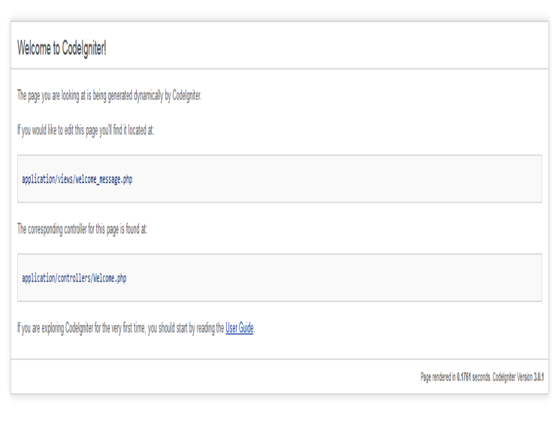
3.Application Architecture:

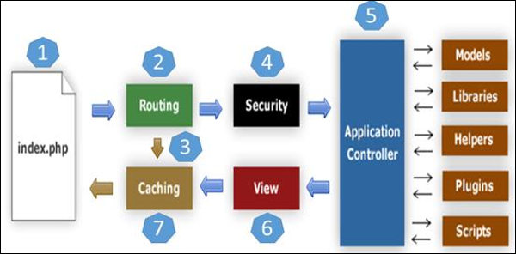

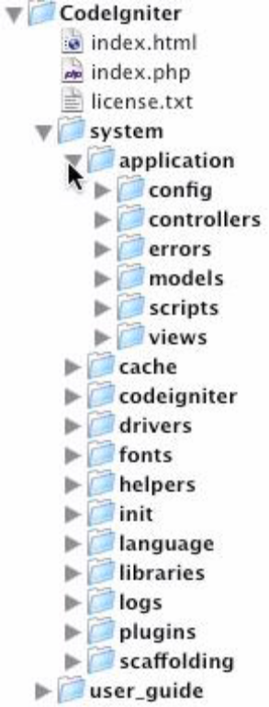

Code Igniter directory structure is divided into 3 folders:
- Application
- System
- User guide

4. CodeIgniter – MVC Framework

Code Igniter is based on the Model-View-Controller (MVC) development pattern. MVC is a software approach that separates application logic from presentation. It permits your web pages to contain minimal scripting since the presentation is separate from the PHP scripting.

- The Model represents your data structures. Typically, your model classes will contain functions that help you retrieve, insert and update information in your database.

- The View is information that is being presented to a user. A View will normally be a web page, but in Code Igniter, a view can also be a page fragment like a header or footer. It can also be an RSS page, or any other type of “page”.

- The Controller serves as an intermediary between the Model, the View, and any other resources needed to process the HTTP request and generate a web page.

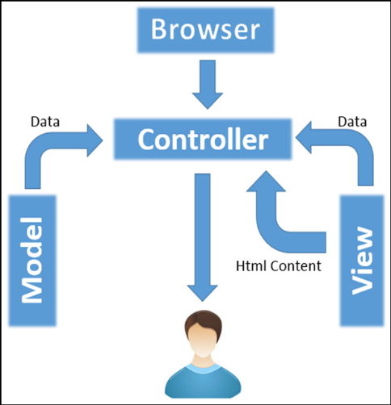
CodeIgniter – MVC Framework

Reasons why code igniter is better than other PHP Frameworks:

1. Execution Time: The first and the most important point which attracts the every developer towards the PHP, is its execution time.
Php gives the response too fast that till now no technology is in this world which can give the execution so fast.

2. File Organization: When you first install the code igniter framework at that time only it contains the many files application which contains the sub-folders as controller, config, model, view etc. This is the main folder which we have to deal to implement the project.

3. Configuration: Code igniter mvc framework has very simple configuration, you just have to fist install the framework as per your system configuration then at the time of programming open the config.php load the library, database, arrays all in that and save that’s it then. You don’t have to write the database name every time to use it. “Write once uses everywhere”.

4. Security: In PHP you will find many in-built functions to use in our project for the input and output filtering. Many function available to for the encryption and decryption which helps the developer to send any data in the secret installation.

5. Less Code and faster development: The php is called as the rapid development framework. You will write less code, which means less time spent typing. You will not have to chase down 3rd party libraries all the time for every new project because most of them will come with the default framework install.

6. Community Support: As we all know that PHP is world’s largest using language so everyone come with their problem and solutions so in those problems and solutions you get your problem solved in very less time and with full support and all. Because so many people using it that after completing the project they just put the source code on the internet from their you can get your result.

7. Easy Error Handling: Error handling was never before so easy but in code igniter you have to only write one line code to enable all the errors in front of you so that you can get what is the problem in the development code.

8. Step by Step Testing With Development Phase: You can test the performance and the functionality of the project during the starting phase of project through that you can see each and every phase of the project and you can test it.

9. Easy Template Solution: Now in world most of the projects are going based on the templates only. Template gives the complete idea of design of project even at starting phase of the development you just have to give the content in that.

10. Code igniter Cache Class: I think most of the clients love to make the cache class in their project because cache what do if you clicked on any button in the project then next time it gives the result from the cache instead of executing the completing the complete code again after clicking.

B. Aptana Studio 3 to create web application

Aptana Studio 3 is an open source integrated development environment (IDE) for building web applications. Based on Eclipse, it supports JavaScript, HTML and CSS with code-completion, outlining, JavaScript debugging, error and warning notifications and integrated documentation. Additional plugins allow Aptana Studio to support Ruby on Rails, PHP, Python, Perl, Adobe AIR, Apple iPhone and Nokia WRT (Web Runtime). Aptana Studio is available as a standalone on Windows, Mac OS X and Linux, or as a plugin for Eclipse.
The Aptana platform is primarily designed for building integrated development environments. It is a highly extensible platform, rather than a custom tool for a specific set of tasks. The Aptana platform defines the mechanisms and the rules, and allows tools to be built on the top of them by providing a set of well-defined APIs. Aptana offers additional features which are targeted specifically at web development compared to Eclipse. It is possible to install Aptana either as an Eclipse plugin or as a standalone version because Aptana Studio builds on Eclipse. Experienced users who have already worked with the Eclipse IDE can integrate the Eclipse plugin in their existing Eclipse installation. Users with less experience can install the standalone version as it works without having an Eclipse installation.
Aptana Studio 3 provides the following support for PHP application development:
- Syntax Coloring according to the selected theme in the preferences.
- Code Assist.
- Syntax error annotations.
- Auto identifications and Code Formatting;
- Hyper-linking to classes, functions and variables by hovering over elements and pressing the Ctrl key.
- PHPDoc popups when hovering over items that have attached documentation.
- Read and write Occurrences Markers when clicking on specific PHP elements
To develop web application in aptana (STANDALONE)
- Type in your Internet browser "aptana.com". Choose Products and then click on Download Aptana Studio 3. In the next step we can choose if we want the Standalone or the Eclipse plug in version. Your OS will be automatically recognized. Then you put in the name and e-mail address and click Download Aptana Studio 3.

- Start the installation by double clicking on the installation file that you just downloaded.
1. In the first step of the installation click on Next
2. In the second step of the installation click on I agree (if you agree with the terms of use)
3.In the third step choose the installation path and then click on Next
4. In the fourth step click Next
5.In the fifth step choose the files that will be automatically opened in Aptana
6. In the sixth step click Install and wait
7. In the seventh step click next
8. Click close to end the process of registration
Importing Existing project to aptana (importing code igniter)
1. Click Import Button
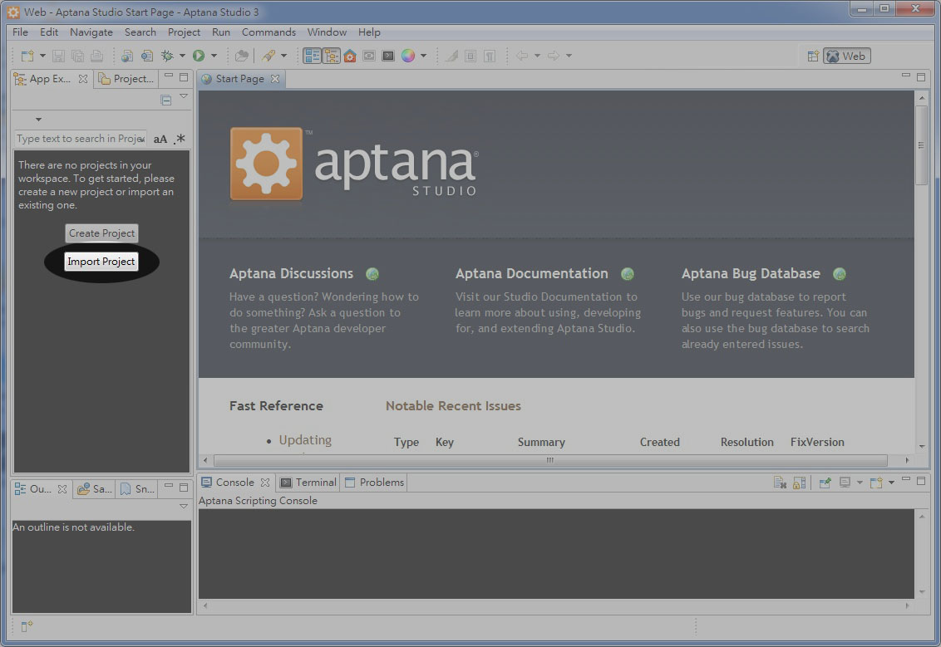
2. Browse the existing project (code igniter from local disk)
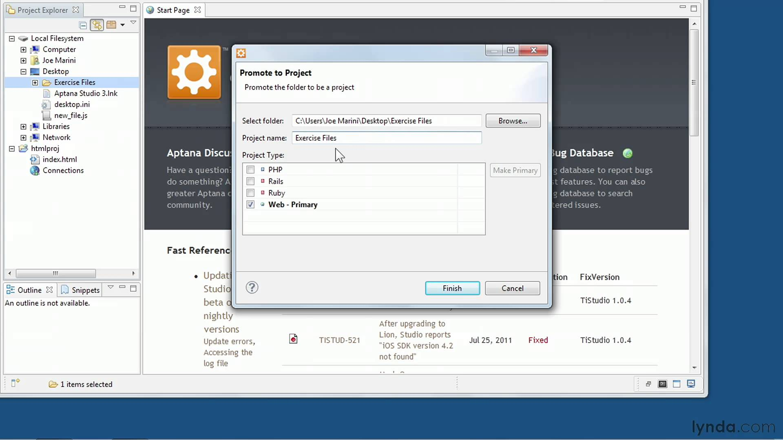

c) Wamp Server as Backend

WAMP Stands for "Windows, Apache, MySQL, and PHP." WAMP is a variation of LAMP for Windows systems and is often installed as a software bundle (Apache, MySQL, and PHP). It is often used for web development and internal testing, but may also be used to serve live websites.
The most important part of the WAMP package is Apache (or "Apache HTTP Server") which is used run the web server within Windows. By running a local Apache web server on a Windows machine, a web developer can test webpages in a web browser without publishing them live on the Internet.
WAMP also includes MySQL and PHP, which are two of the most common technologies used for creating dynamic websites. MySQL is a high-speed database, while PHP is a scripting language that can be used to access data from the database. By installing these two components locally, a developer can build and test a dynamic website before publishing it to a public web server.
While Apache, MySQL, and PHP are open source components that can be installed individually, they are usually installed together. One popular package is called "WampServer," which provides a user-friendly way to install and configure the "AMP" components on Windows.
The "P" in WAMP can also stand for either Perl or Python, which are other scripting languages. The Mac version of LAMP is known as MAMP.
